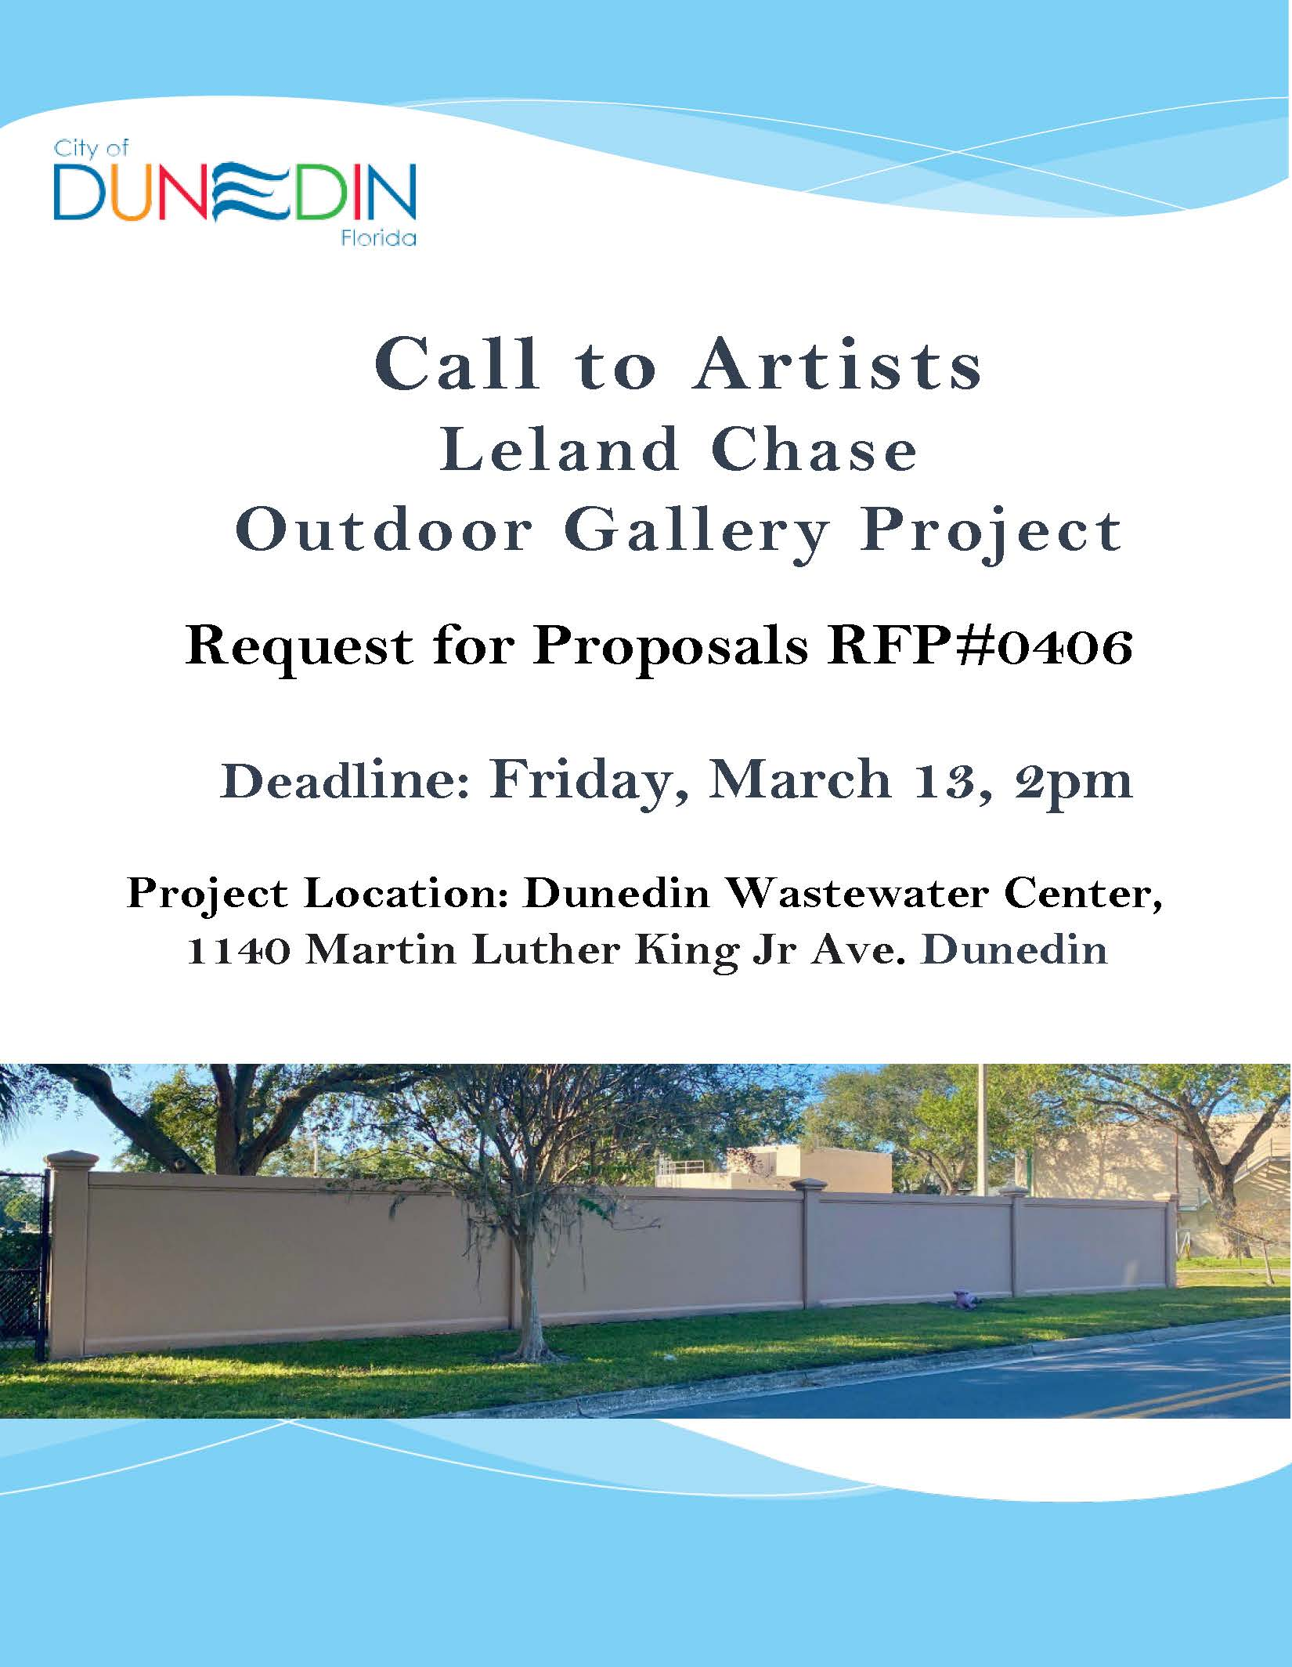
Call to Artists / Request for Proposals (RFP#0407):

Project Title: The Leland Chase Outdoor Gallery Wall

About The Leland Chase Outdoor Gallery Wall:
Angela Chase and Lorraine Leland exemplified the strength of community collaboration as they worked together to create meaningful educational opportunities for students moving from Chase Memorial School to Dunedin Schools beginning in 1963.
This project honors them for their significant contributions to a historic neighborhood settled in the 1880s by Black workers seeking employment on the Orange Belt Railroad. Almira Chase founded and served as the first principal of Washington School and Social Center (1915), which was established for Black students under Florida’s segregation laws. The school was later renamed Chase Memorial Elementary School. It closed in 1963 after desegregation.
After the school's closing, Lorraine Leland responded to the need for educational support by coordinating the successful Dunedin Educational and Enrichment Program (DEEP). The Leland Chase Outdoor Gallery reflects the historic contributions of both women and encourages meaningful collaborations.
Total Budget: $4,000. (includes up to 6 artist licensing fees of $100. each plus materials, fabrication, installation, and ID plaques)

Deadline for Submission (Email Only): Received by 2:00 pm Friday, March 13, 2026

Eligibility: Open to professional and student artists who legally reside in Pinellas County.

Funding Partners: The Funding partner is the City of Dunedin and The Dunedin Public Art Fund.

• The City of Dunedin Arts & Culture Advisory Committee (ACAC) is requesting submission of art work for public display to be installed on the Leland Chase Outdoor Gallery Wall at Dunedin Wastewater Center, 1140 Martin Luther King Jr Ave. Up to 6 artworks may be selected for 4’T x 6’W mural-like display.

• New or existing works in any 2D media (including photography, painting, digital, drawings, print, etc.) that support the theme of collaboration can be submitted. Artists may view images currently installed at Leland Chase Outdoor Gallery - City of Dunedin, FL

• Works shall be initially submitted as digital images not to exceed 1 MB. The best digital file formats for large prints are TIFF and PDF. Name the image file: the email shall include the digital image titled with artist surname and title of work (for example, Picasso-Guernica.jpg).

Please note: If selected, artists are required to provide a final image file, a vector art file (pdf or tiff), at least 150 dpi Full Size, or 300 dpi Half Size for selected image(s).

• In the body of the email: artist’s name, any art affiliations, e-mail, phone number, address and title of work. If the artwork is selected, a high-resolution photo shall be provided by the artist for printing.

• Images will be reviewed and selected by the Leland Chase Outdoor Gallery Subcommittee, a subcommittee of the Arts & Culture Advisory Committee. Preference will be given to Dunedin residents.

• Selected artists will be paid a $100. licensing fee for use of each digital image(s) of their original artwork(s). A maximum of two images per artist can be submitted.
The artist will retain the original work, and it may be offered for sale by the artist. Artist finalists may be offered this fee for one mural each.

• The Call to Artists is available on https://www.dunedingov.com/Activities-and-Recreation/Arts-Culture.

• Information about the selected artworks and artists will be available on https://www.dunedingov.com/Activities-and-Recreation/Arts-Culture.

• Deadline for Submissions (By Email Only): 2PM, Friday, March 13, 2025

• Email Submission to PublicArtDunedin@gmail.com

• Final Selections to be made on or by: March 16, 2026
Artists will be notified via email within 48 hours of the Subcommittee meeting.
• Final approval of selections subject to vote by the Dunedin City Commission on Tuesday, __________________ (date TBD)

Please do not call or email for an update on the status of your submission.

